Book8 Unit 2 Good manners（B2）
教学内容：
本课是Primary English for China第八册四年级下学期，Unit2 Good manners Part B2部分的学习内容，本节课将学习一些常见的涉及规章制度的词汇，结合祈使句，You should/ shouldn’t…句型，以设计各种场所或活动中的规章制度为语言功能， 以生活中他人的行为为具体话题，将语言融于实际交流中，培养学生良好的行为规范。
教学目标：
1.知识与能力目标：
◆ 复习A部分的短语: run in the corridors, walk in the corridors, be rude, be noisy, throw rubbish on the floor, throw rubbish in the bin, be polite, be rude.
◆ 能用运用新句型You should… /You shouldn’t…规劝他人，并给出建议，并能够写出一些规章制度。
2.过程与方法目标：
◆ 结合实际生活情景，灵活运用句型You should… /You shouldn’t.
3. 拓展目标：
◆ 让学生在不同场景中进行言语交际，提升学生综合运用语言的能力。
4.情感态度价值观目标：
◆培养学生养成文明礼仪，遵守公共规范的习惯。
教学重难点：
1.教学重点：
◆句型You should… /You shouldn’t…
2.教学难点：
◆ 灵活运用句型You should… /You shouldn’t…给他人提出建议。
教学方法：
◆ 任务型教学法、情境教学法、多媒体教学法、TPR教学法。
教具准备：
◆ Computer, PPT
教学设计：
Step1 Talking :
- Free talk: Talk about their good friends.
1) Do you have good friends?
2) Who is your good friend?
2. Review the phrases in Part A.
T: I have some friends. (show some pictures) Do you want to make friends with them? Who ？or Why not?
S1: I want to make friends with… Because she/he is…
S2:I don’t want to make friends with…Because she/he is…
Now talk this picture with your friends.
设计意图：通过谈论身边的朋友，借助生活情景性，引导学生判断哪些是好的行为习惯，哪些是不好的行为习惯，从而有效复习旧知，引入新知，激发学生学习兴趣。
Step2 Teaching:
- 教师根据A部分图片继续发问：
T: What do you want to say to …?
S: … don’t…please…！
由此引出本课新句型：You should… /You shouldn’t…
Question: Is Lucy good？What should she do? What do you want to say to her?
Guide them say: You shouldn’t be noisy.
You should be quite.
(Teaching the sentence: You shouldn’t be rude. /You should be polite.)
- 教师提供两篇阅读材料(一篇关于A部分重点单词和句型的内容以及祈使句在情景中的运用，另一篇关于新授句型的运用)，让学生自主听读，强化巩固新授句型。
- Pair work: 教师呈现A部分图片，并提供语言支架，帮助学生进行巩固强化新知，到达知识点的灵活运用。
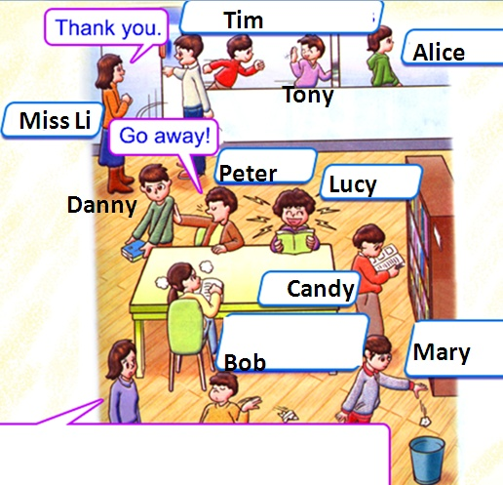 | Key structures:  A: Look at ... What’s she/he doing?  B: She/ he is …  A: Is she/ he good? What should she/ he do?  B: She/he shouldn’t…She/he should…
设计意图：通过学生在A部分学习的场景，借助学生已有的知识，让学生灵活运用新句型You should… /You shouldn’t…进行谈论，强化生生交际，突出语言的层次性。
Step3 Training:
- Listen and read more: Reading1.2.3
T: Let’s listen more about rules.
设计意图：通过自主听读，进一步强化新授知识的学习，理解新句型在不同场景中的灵活运用，同时还能拓展一些书本以外的行为规章制度，给学生提供语言积累，为学生的综合输出奠定基础。
- Pair work: 教师出示4幅不同场景的图片，并提供语言支架，帮助学生进行语言知识的运用和交际。
T: We have known about some rules. But, do you know what we should do or we shouldn’t do in our daily life? Here are some pictures, what should they do?
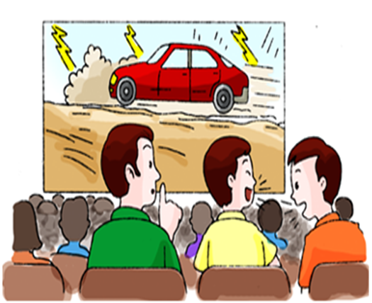 | 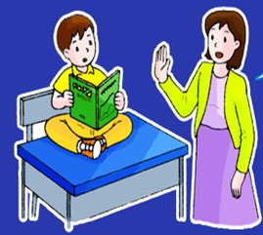
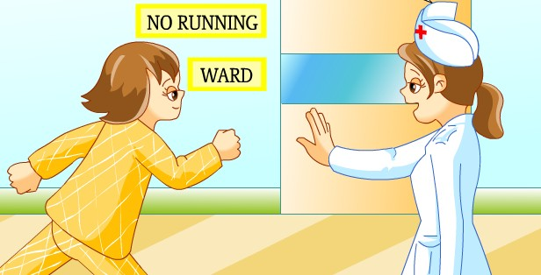 | 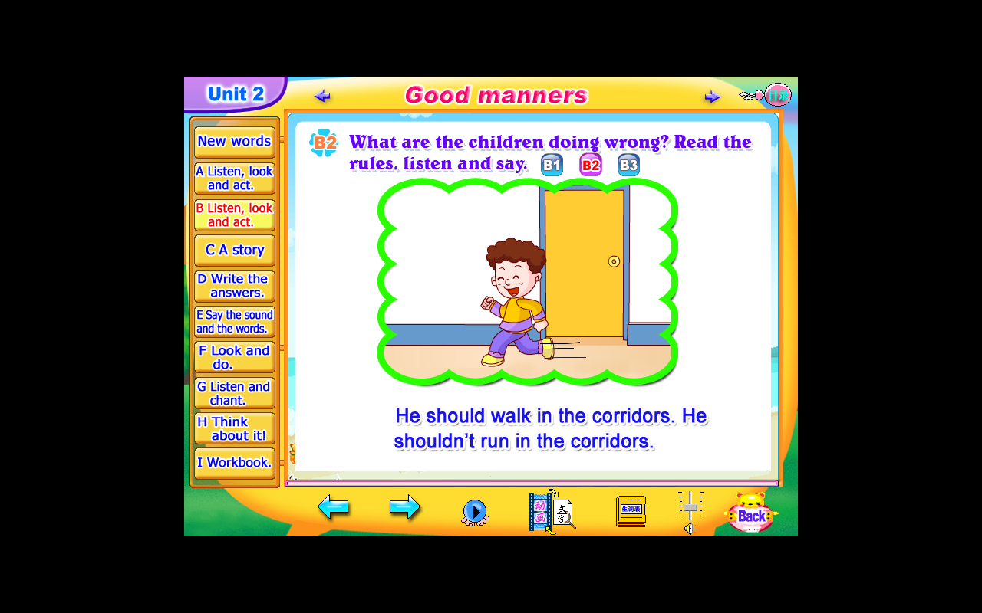
Key structures:
A: Look at this picture. Who’s the girl/boy?
B: She /He is…
A: Where is she/ he?
B: She /He is in the…
A: What’s she/he doing?
B: She/ he is …
A: Is she/ he good? What should she/ he do?
B: She/he shouldn’t…She/he should…
设计意图：在综合拓展环节，通过给出几个不同的场景，让学生在一个真实语境中进行生生交际，将语言融于实际交流中，达到融会贯通的效果，提升语言综合运用能力。
- Let’s write: Design the rules in our daily life.
Here are some places (library/ swimming pool / meeting room/ park /school…). Choose one of the places or activities, and write down what we should do and we shouldn’t do.
Eg: Rules in the swimming pool
You should wear swimming suit. You shouldn’t throw rubbish in the pool. You should throw rubbish in the bin. You shouldn’t run around the swimming pool. It’s dangerous.
设计意图：通过给学生提供出几个不同生活场景让学生结合实际生活的文明礼仪，制定相应规章制度，从而在渗透情感教育，培养学生良好的行为规范同时，提高中年级学生的写作水平。
Home work：
- Listen to the tape and read Part A&B.
- Let’s talk and write: If you want to be a model student, what we should do in our daily life.
Eg: I should… I shouldn’t…

